
CONFIDENTIAL: The BumpTop Executable and this document is confidential intellectual property. DO NOT DISTRIBUTE.

BumpTop
Instructions for Use

BumpTop is still under development and as such you may experience crashes or inconsistent behaviour. The best solution for the time being is to restart the program. An example use of BumpTop can be seen in the

Basic Interaction
In BumpTop icons are dragged or tossed to move them. Many basic interactions are performed by the LassoMenu. The LassoMenu is invoked when circling to select objects and closing the lasso by entering the blue circle that appears where you started and pulling out in the direction of the desired interaction. After you select your interaction the rest of the pen movement will let you adjust it. The LassoMenu options are different when selecting single items, multiple items, piles or empty selections. Note: Releasing the mouse/pen while inside the blue circle does nothing, you must pull out of the LassoMenu in the direction of the command to engage an interaction.
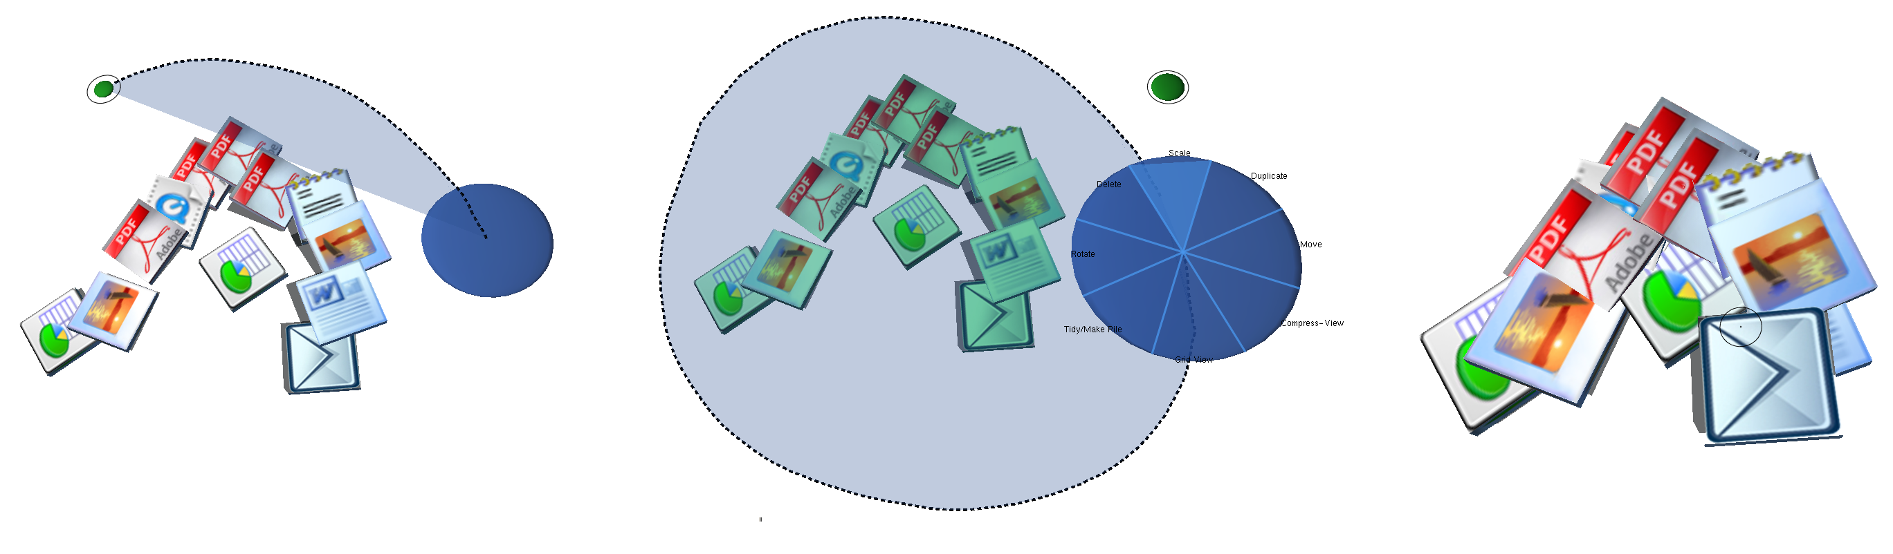
Figure 1 LassoMenu

Creating Piles
Piles can be created out of documents with the LassoMenu, however the easiest and most elegant way to create piles is with Lasso’n’Cross. You simply lasso around the objects you would like to pile and then cross the icon that appears at their center.
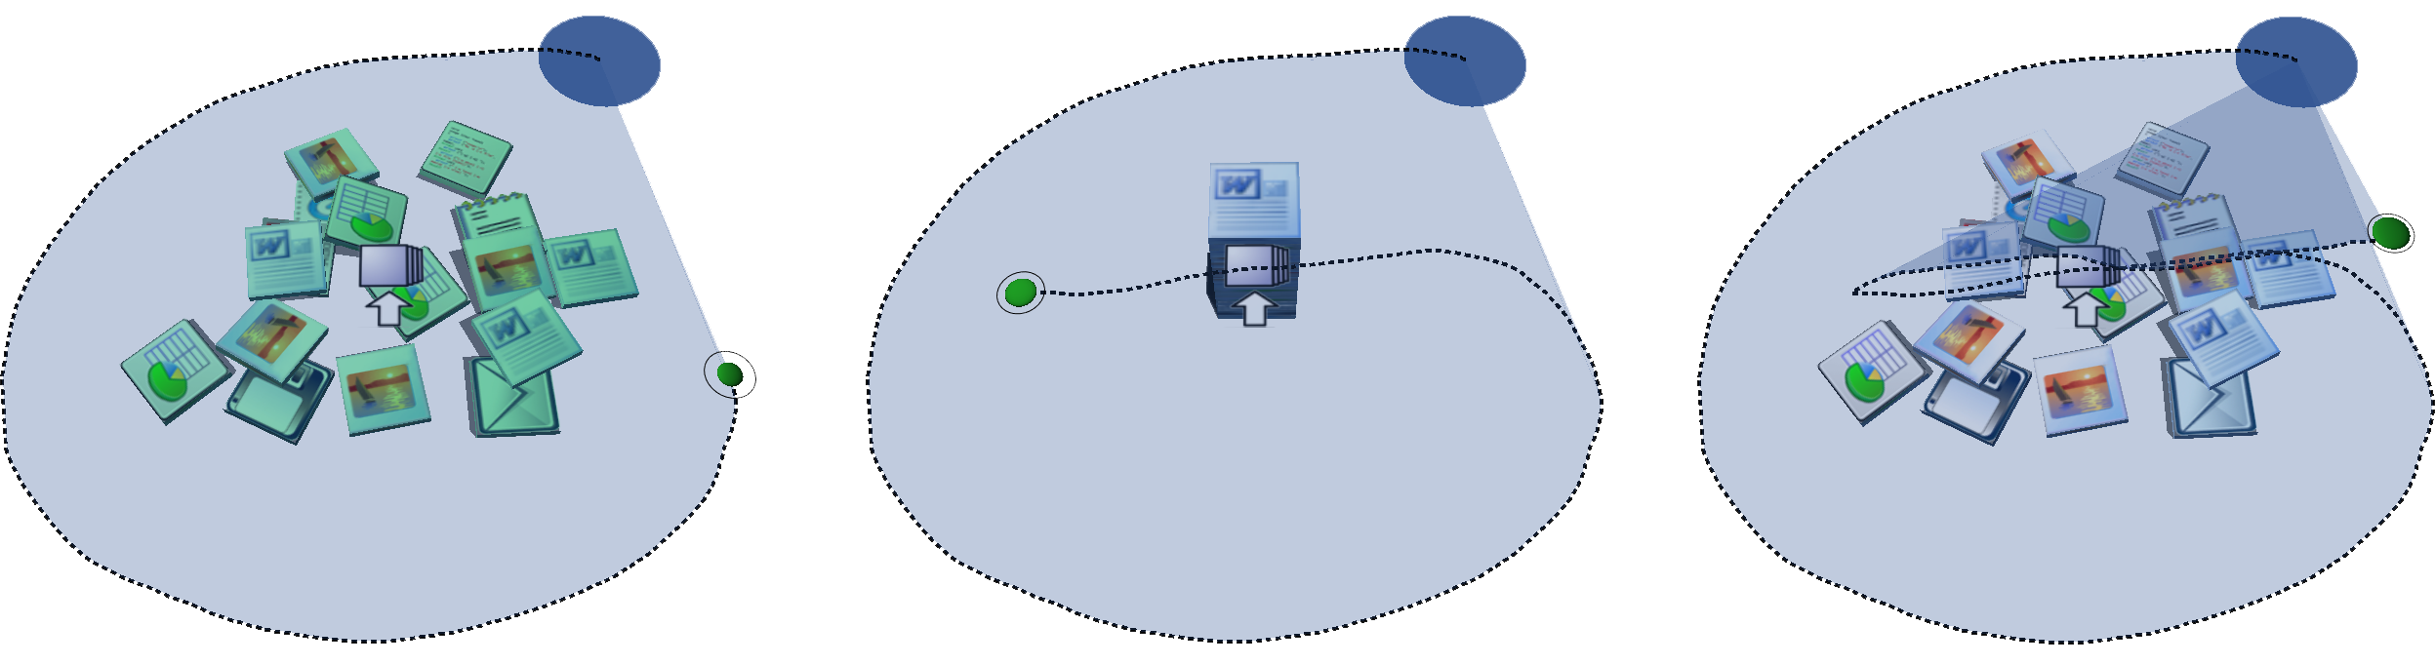
Figure 2 Lasso'n'Cross
Browsing Piles
Piled items can be browsed or manipulated by clicking or crossing on one of their Widgets and keeping the mouse down. In all but the moving and pile-breaking widget, when you release the pen things to back to normal.
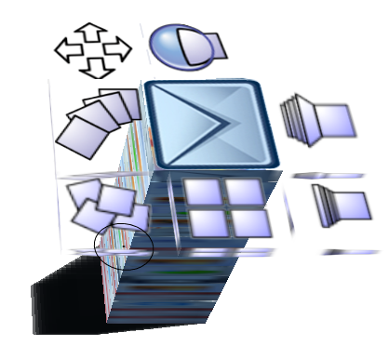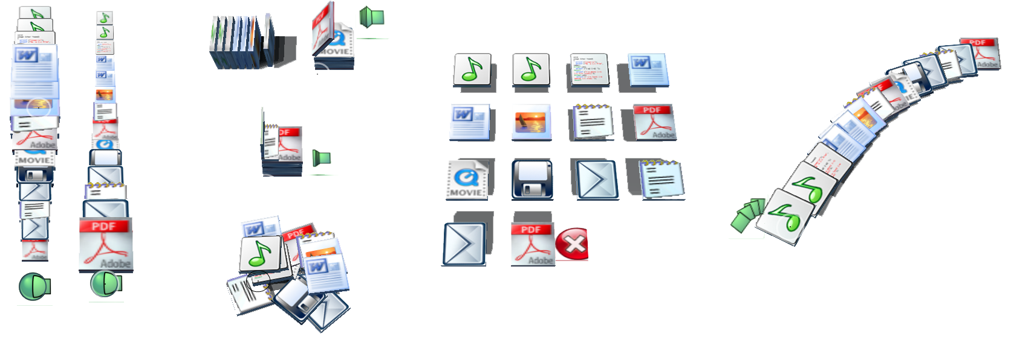
Pile Widgets Different ways to browse a pile contents

To keep things laid out you can use the PressureLock technique where you push hard with the pen until the green circle fills the cursor and turns white. If you aren’t using a pressure sensitive pen, a right-click will also work. Click the Red X to go back to how things were.

You can also use PressureLock/Right-click to pin items up to the wall when you’re dragging over it. Pull them off the wall to remove them. Double-click on the wall or floors to focus the camera on them.

Changing the View
Mouse Looking
You can use the mouse to move around in the scene, it is fully 3D.
-Pan by holding the right-mouse button and moving left to right.
-Zoom by holding the right-mouse button and moving up and down
-Rotate by holding the middle-mouse button and moving in any direction

Zoomable UI
To shift focus to the walls or floor, simply double click on it. To return to the default view push the ‘t’ key or push ‘r’ for a top-down view. You can zoom to your selection by selecting “Zoom to Selection” from the LassoMenu. Pushing ‘a’ zooms so you can see verything. Push the ‘l’ key to remove the walls enclosing the BumpTop space.

Pulling in Content
Images
To insert an image (jpg, gif, png, tif, tga, etc) into BumpTop push ‘q’ on the keyboard and enter a URL, filename or directory that contains photo(s). Push F1 to paste from the clipboard. Note: directories with images may be quite large and takeup more space than the enclosed default BumpTop space, so it is best to disable walls by pushing the ‘l’ key when dropping in large photo sets. The ‘u’ key drops in high-quality preloaded images, ‘y’ drops OS windows, and ‘b’ drops album covers.

Web and Flickr Searches
To search the web using snap.com push ‘s’. To search using Flickr push ‘h’.

Advanced Interaction
-Keymap.xls shows what keys trigger what advanced functionality. Some of this functionality is for debug purposes and may not produce any recognizable effect.

